What about variable inside individual execution context?

On top of execution context, we have variable environment

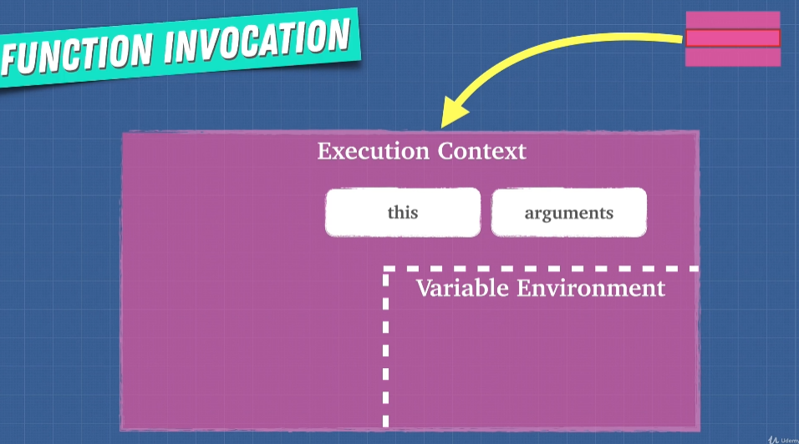

Scope Chain

Understand variable lexical. All function access to global variable

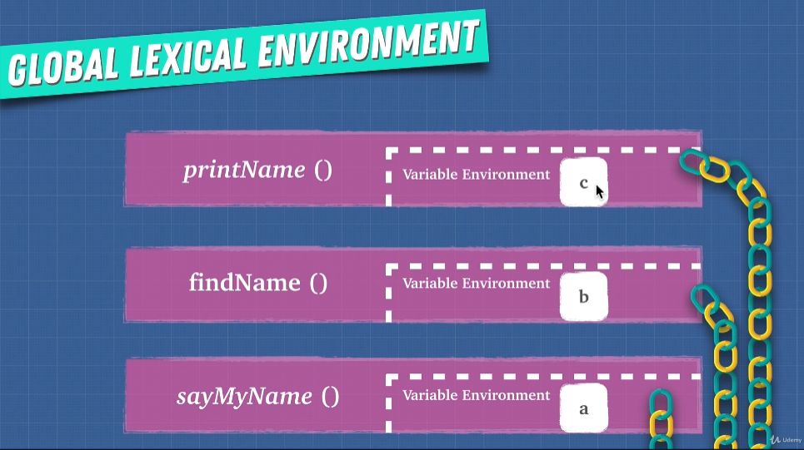

The link called scope chain for function to have access to the global environment. Function will search the variable locally first, if don’t exist of that variable, it will go search global (The parent environment)

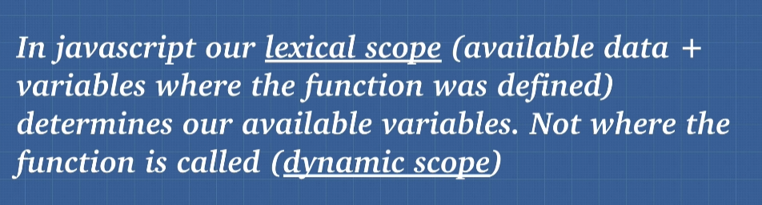

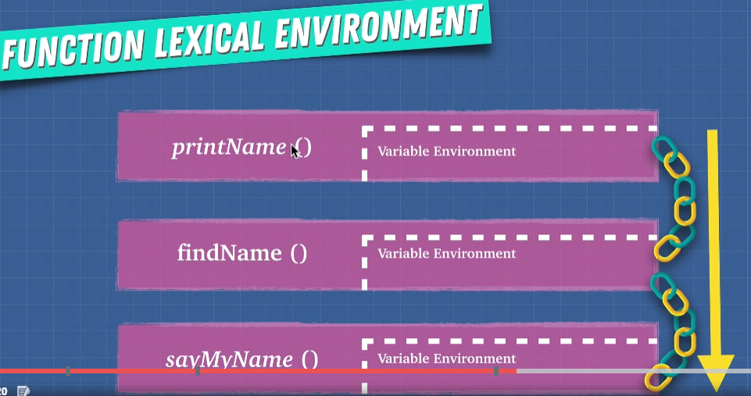

sayMyName()()(). Scope is searching through for your variable via the chain. Consider you search a variable that exist in printName, you invoke it in findName, it will not work since that variable only defined in printName, scope search at its parent environment

